fRNC Tutorial

Methods
Construction of the basal RBP-ncRNAs network
The mutual interactions among RBPs and ncRNAs (miRNAs, circRNAs and lncRNAs) were extracted from ENCORI database (http://starbase.sysu.edu.cn/panCancer.php). Each interaction has a stringency value (>=1, low; >=2 medium; >=3 high; >=5 strict), where the values indicated the supported CLIP/PARE experimental evidence. There are 5 types of non-directional interactions in the regulatory network: miRNA-lncRNA (M2L), miRNA-circRNA (M2C), miRNA-RBP (M2R), RBP-lncRNA (R2L) and RBP-circRNA (R2C). Table 1 lists the statistics of the interactions with low stringency. As a result, 642 miRNAs, 14281 lncRNAs, 2556 circRNAs and 1271 RBPs constitute 544957 interactions.

Table 1: Summary of the RBP-ncRNA regulation network
 | #miRNA | #lncRNA | #cicRNA | #RBP(mRNA) | #Interaction
M2L | 642 | 3789 |  |  | 63698
M2C | 642 |  | 2075 |  | 63386
M2R | 618 |  |  | 1271 | 125409
R2L |  | 14281 |  | 131 | 201147
R2C |  |  | 2556 | 132 | 91317
Total | 642 | 14281 | 2556 | 1271 | 544957

Users can also provide their own interaction data. The following input format is accepted.
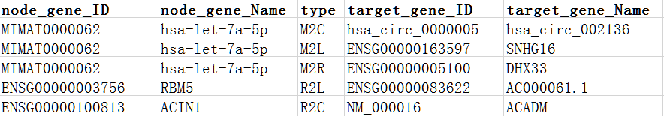
During the construction of regulatory network, the lncRNA and gene names were mapped to Ensembl IDs (http://asia.ensembl.org/index.html), the miRNA names were mapped to miRBase accession numbers of mature miRNAs (http://www.mirbase.org/) and the circRNA names were mapped to circBase ID (http://www.circbase.org/). The RBPs, miRNAs, lncRNAs, and circRNA that did not map to these IDs were discarded.
Expression data pre-processing
The R package fRNC can process the expression data of ncRNAs and mRNA in matched tumor and normal samples from either microarray or RNA-seq platform. For instance, we first download cancer miRNA, mRNA and circRNA expression data from the TCGA database (https://www.cancer.gov/about-nci/organization/ccg/ research/structural-genomics/tcga) and MiOncoCirc (https://mioncocirc.github.io/). Then the DEGs function can use the R package edgeR to perform differential expression analysis for RNA-seq count data. For miRNA expression, we calculated the read counts of each mature miRNA from the isoform quantification files, in which mature miRNA IDs are updated based on miRBase release 22 (http://www.mirbase.org/). Genes in these samples were annotated by the Ensembl 90 annotation of the human genome. The lncRNA IDs were extracted based on the gene biotype in the annotation information. The circRNA IDs are updated by extracting the overlap of circRNA transcripts that are from both MiOncoCirc and circBase. Furthermore, the miRNAs, lncRNAs, RBP (mRNA), and circRNAs that expressed (expression value >0) in at least half of the samples were retained. Some examples of ncRNA and mRNA names can be seen in the following examples.
Users can also provide data after differential expression. The input format is as follows. The column name must contain genes, log fold change (logFC, optional), P Value and type. The row name is the gene identifier.
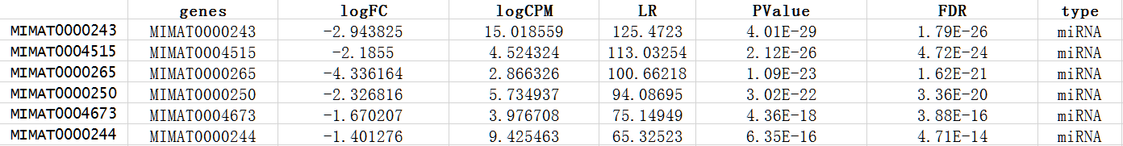

Survival analysis
The corresponding clinical data such as survival time can also be used. The fRNC package evaluates each gene (node) by calculating the P-values from a univariable Cox proportional hazards regression model with the R package survival, which quantifies how significantly the expression data of the node correlated with the corresponding patient clinical data.

Identification of the dysregulated RNCs
The fRNC package contains two sub-network searching algorithms: fast exact and greedy search approach. For both methods, the summary score for a RNC is defined in as
where k denotes the number of nodes in the network. z_{i} indicates the score of the node.
When users choose the method of "global", the fast exact approach was used to calculate high-scoring RNC from the whole network. The following depicts a short outline of the algorithm:
1. Given a set of P values from either differentially analysis or survival analysis, they are first transformed to a node score as proposed in R package BioNet. Then all positive connected nodes are aggregated into meta-nodes based on the different connected sub-networks decomposed from the whole network.
2. The node scores are transformed to the edge scores based on the node that an edge linked.
3. All paths between positive meta-nodes are calculated based on the minimum spanning tree (MST) of these edge scores. It can include negative scoring nodes.
4. The highest sub-networks score is calculated on a MST, in which the negative nodes and positive meta-nodes were connected.

When users choose the method of "local", the searching algorithm is greedy search approach. Briefly, the score of z_{i} was calculated from P value according to z_{i} = Φ⁻¹(1 - p_{i}) (p indicated the significance of expression change determined by edgeR package), The φ⁻¹ represents the inverse normal cumulative distribution function.
1. Assigning a seed node by the user. Firstly, the sub-network only contains the seed node. Z_{m} of the seed sub-network is computed.
2. Identifying neighborhood nodes, whose shortest path to any node in the sub-network is shorter or equal to a distance d (e.g., d = 2). In other words, identifying the all connected neighborhood nodes with a distance d around the sub-network.
3. Exploring the neighborhood nodes defined in 2 and find which nodes can generate the maximum increment of Z_{m}. If the increment (Z_{m+1} - Z_{m}) is greater than Z_{m}×r, the nodes will be added into the sub-network, where r is the rate of proportion increment (Z_{m+1 >} Z_{m}×(1+r)). Here, the r is set to 0.1.
4. Keeping going 2‐3 until any neighborhood nodes added into the current sub-network cannot yield an increment that is greater than Z_{m}×r.

Lastly, to evaluate the statistical significance of the sub-network identified by the two searching algorithm. It uses random sampling to see if the score of the sub-network is significantly higher than that of a random node set in the network. In this way, we randomly samples node sets with the same number 100 000 times. The mean μ_{n} and standard deviation σ_{n} are estimated from the sampled nodes. Finally, sub-network (i.e. RNC) score is evaluated further normalized by

Example
Esophageal carcinoma data collection and pre-processing
We downloaded miRNA, mRNA and circRNA expression data of esophageal carcinoma (ESCA) and normal samples from TCGA and MiOncoCirc. The miRNA, mRNA-seq data consist of 161 tumors with 11 normal samples in the TCGA, and circRNA data with 19 tumors and 25 normal samples in MiOncoCirc. The miRNA-lncRNA and miRNA-circRNA interactions were extracted from ENCORI with a high stringency, where the number of the supported CLIP experimental evidence is 3 or greater. The R package edgeR was used to analyze the differentially expressed miRNAs, mRNAs and lncRNAs. The result was saved with the data "dataN".

Case 1
The major aim of this analysis is to detect ncRNA RNC by the "global" method from miRNA-lncRNA-circRNA regulation network in ESCA.
First of all, we load the fRNC package and the required data sets, containing a human ncRNA interaction network, logFC and p-values.
> library(fRNC)
Then, we extract interactions according to stringency with number of supported experiments (>=1, low; >=2 medium; >=3 high; >=5 strict) and interaction type with either the RBP-ncRNA network or the ncRNAs (miRNA-circRNA, miRNA-lncRNA) network. In which, M2L indicates miRNA-lncRNA interaction (M2C: miRNA-circRNA, M2R:miRNA-RBP, R2L:RBP-lncRNA, R2C:RBP-circRNA). Here, we set stringency with "high" and type "ncRNA" in the function interStringency. Meanwhile, we need to generate corrected p-value based on p-value and logFC with the formula: 2 × (1- log₁₀P-value × |logFC|) (the parameter islog = TRUE ), and deal with unreasonable p-value in the function combinp. Thus nodes with zero p-values are assigned to the minimum p-value of the remaining nodes. The nodes with p-value of 1 are deleted directly.
> head(dataN)
genes type logFC logCPM PValue FDR
ENSG00000163328 ENSG00000163328 lncRNA -4.324457 5.482506 4.26e-66 6.60e-62
ENSG00000174514 ENSG00000174514 lncRNA -5.250937 5.688601 1.83e-47 1.42e-43
ENSG00000050628 ENSG00000050628 lncRNA -4.527529 3.581380 3.50e-44 1.81e-40
ENSG00000164850 ENSG00000164850 lncRNA -4.077812 2.842756 6.13e-44 2.38e-40
>gene2weight<- combinp(dataN[ ,c("type","logFC","PValue")], islog = T)
>interac <- interStringency(type = "ncRNA", stringency = "high")
In order to constructing the reliable and refined ceRNA network, we used the criteria of the shared number of miRNAs > 50 and hypergeometric probability <0.05 of common miRNAs by a lncRNA and circRNA to identify lncRNA-circRNA pairs with the function cepair. It may run for a few minutes depending on the computational environment.
>interac_high_p_50 <- cepair(interac, N_mi= 50)
>interac_str <- interac_high_p_50[ ,c("node_gene_ID", "type", "target_gene_ID")]
> head(interac_str)
node_gene_ID type target_gene_ID
16 MIMAT0000062 M2C hsa_circ_0000249
18 MIMAT0000062 M2C hsa_circ_0000384
29 MIMAT0000062 M2C hsa_circ_0000593
37 MIMAT0000062 M2C hsa_circ_0000799
40 MIMAT0000062 M2C hsa_circ_0000810
44 MIMAT0000062 M2C hsa_circ_0000962
Now we used a fast exact approach to calculate the maximum scoring sub-network to identify the "global" RNC with the parameter of "global" in the main function by a FDR of 1e-14. The smaller the FDR was set, the smaller the sub-network can be obtained. Such a low FDR was chosen to obtain a small sub-network.
>res.list_global <- runmodule(network = interac_str, gene2weight, method = "global", FDR = 1e-14, issymbol = T)
>names(res.list_global)
"GNCW" "module" "module.score.matrix"
#GNCW, an object of igraph class, is the node‐weighted ncRNA network.
#module, an object of igraph class, contains the gene in GNCW and the weight
#module.score.matrix, an object of matrix, contains data for the module: Zm (module score),
Zn (normalized module score). The higher the z_{i} value is, the more reliable of the module it is.
We saved the result as XGMML file and then observed it in the Cytoscape environment, where coloring and changing the node shape can be manipulated according to the "type".
>saveNetwork(res.list_global$module,file="ceRNA_module",type = "XGMML")
Following figure is the dysregulated RNC in ESCA ncRNA network. The miRNA node is represented by black square, lncRNA by purple triangle and circRNA by yellow circle.
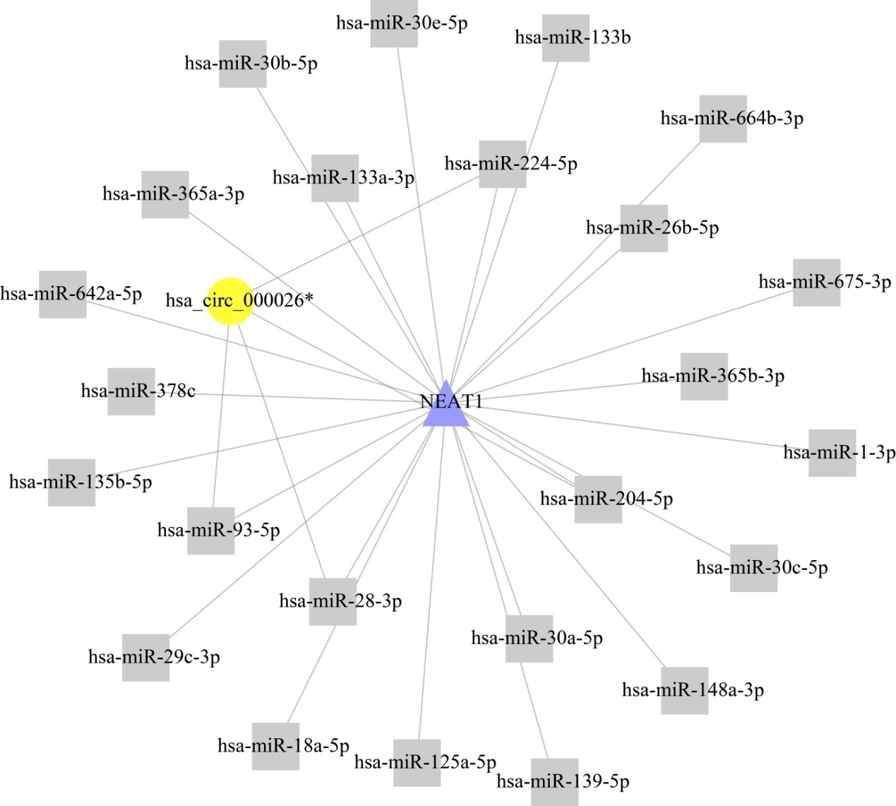

Figure 1. The "global" RNC identified for ncRNAs network in ESCA

Case 2
The major aim of this analysis is to detect RNC containing one RNA binding protein “HNRNPC” by the "local" method from miRNA-lncRNA-RBP regulation network in ESCA.
First of all, we loaded the miRNA, mRNA expression data of the ESCA cancer and normal samples separately. Then we loaded the survival data. DEGs function was used to identify the differentially expressed miRNAs and mRNAs, and to assign the type attribute to each node. By setting the parameter 'data_type', the DEGs function can handle expression data generated from either sequencing or microarray platform.
>data("case.exp_miRNA")
>data("control.exp_miRNA")
>result_miR <- DEGs(case.exp_miRNA,control.exp_miRNA, geneid= rownames(control.exp_miRNA), data_type = "RNAseq_counts")
>data("case.exp_rna")
>data("control.exp_rna")
>result_rna <- DEGs(case.exp_rna,control.exp_rna, geneid= rownames(control.exp_rna), data_type = "RNAseq_counts")
You can also evaluated each node by calculating the P-values from a univariable Cox proportional hazards regression model between survival data and corresponding normalized expression of node in the function DEGs.
>data("clinData")
>result_clin <- survival.miR_rna(miRNA_profile=result_miR$Nor_expr, gene_profile = result_rna$Nor_expr, clinData = clinData)
>dataNo <- rbind(result_miR$DEGs, result_rna$DEGs)
>gene2weight <- combinp(dataNo[,c("type","logFC","PValue")], islog = T)
>interac_RBP <- interStringency(type = "RBP",stringency = "high")
> interac_RBP <- interac_RBP[,c("node_gene_ID","type","target_gene_ID")]
Then we filtered some nodes in the expression profile, in which their type were not miRNA, RBP and lncRNA.
>loca_miRNA <- which(gene2weight$type== "miRNA")
>loca_RBP <-which(gene2weight$type== "RBP")
>loca_lncRNA <-which(gene2weight$type== "lncRNA")
>gene2weight_type <-gene2weight[c(loca_miRNA, loca_RBP, loca_lncRNA),]
Based on the P value generated from differential analysis, we used the greedy algorithm to calculate the scoring sub-networks of the seed in each node with the method of "local". By the parameter seletN, users can assign the node set as the seeds with ensemble ID and miRBase miRNA ID. For example the "ENSG00000092199" is ensemble ID for HNRNPC. The size of the resultant RNC can also be set with 5-15 by the parameter of "node" in the main function runmodule.
>res.list_local <- runmodule(network = interac_RBP, gene2weight_type, method = "local", maxsize=15, seletN = c("ENSG00000092199", "ENSG00000066044") )
>names(res.list_local)
"GNCW" "module" "module.score.matrix"
#GNCW, an object of igraph class, is the node‐weighted ncRNA network.
#module, an object of list, contains all the valid modules, the name of each record is the seed
gene.
#module.score.matrix an object of matrix, contains data for the seed module: Z_{m} (module score),
Z_{n} (normalized module score).
Finally, the output is loaded and plotted with the following commands. The local sub-network of " ENSG00000092199"(HNRNPC) can also be saved as XGMML file for further analysis.
>list_local <- res.list_local$module
>savelocalM(res.list_local)
The following figure is the resulted RNC containing one RNA binding protein “HNRNPC” in ESCA. Users can observe it in the Cytoscape environment. The miRNA node is represented by black square and RBP node by blue triangle.

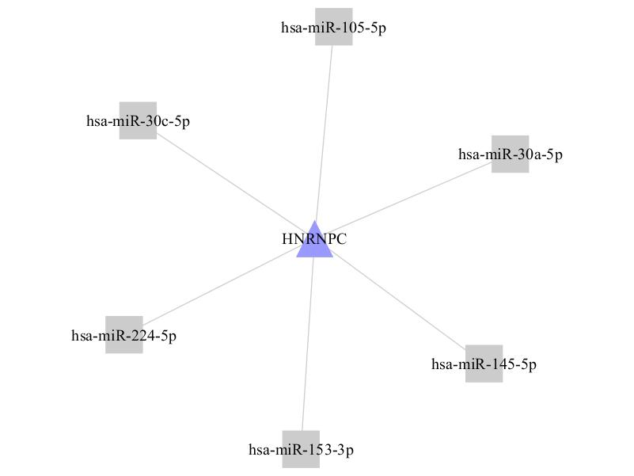

Figure 2. The "local" RNC starting from HNRNPC for RBP-ncRNA network in ESCA

